Week 15 Individual Logbook
Capstone project
Matt Baker
2026
Table of Contents
Hours Breakdown 2
Completed Content/Documentation 3
Team Meetings 3
Advisor Meetings 3
Client Meetings 3
Research 3
Documentation 4
Testing 6
Development 6

Hours Breakdown
Category | Hours completed
Team meetings | 3hrs 30min
Client meetings | 2hrs 30min
Advisor meetings | 1hr 30min
Research | 1hr
Development | 45mins
Testing | 2hrs 15min
Documentation | 26hrs 30mins
Logbook preparation | 1hr
Sick leave/specific conditions
Other
Total Hours for this week | 39hrs
Running total of hours completed for  Capstone | 406hrs/450hrs

Completed Content/Documentation

Team Meetings
Tuesday 20th October
10:45 – 12:00PM (1hr 15min)
Logs, auditing, sorting time discrepancies, clarifying who is working on what. Discovering bottlenecks in Sam or Dave with assignments due. Timeline of final panel, how much time they will spend on individual closeout reports.
4:15 – 5:30 (1hr 15min)
Meeting with Sam and Dave, advising Dave on what to take from the research report and how to word some of the content in the poster. Elements to keep and remove.
Friday 23rd October
9:00 – 10:00 (1hr)
Polishing concluding review, doing rehearsal of presentation. Preparing team for presentation.

Advisor Meetings
Tuesday, 20 October
9:00AM – 10:30AM (1hr 30mins)
Meeting with Bryce, all present, piracy, kimdotcom. Legal way they present digital evidence. How final documents are going, scheduling meeting with Geoff. I need to append research report with manuals. Need to figure out exact times of development to use as metrics to compare to.

Client Meetings
Friday 23rd October
10:00-12:30PM (2hrs 30min)
Meeting with Geoff with all present. Prepped him for presentation, lots of open discussion on various topics, actual presentation. Additional work, employing “strata” for additional testing desired by Geoff particularly related to local deployment. We show Geoff our poster, our data, our research report too, too much was covered to make it in the video.

Research
1hr (See research log)
Research was mostly to support the research report.

Documentation
Monday, 19 October
11:45 – 1:00PM (1hr 15min)
Work on research report, referenced discussion on what makes gemma4:26b the best. Table on models used.
Friday, 23 October
2:45 – 6:00 (3hrs 15min)
Reviewing, editing, encoding client closeout meeting video, 2hrs 30 minutes of recording into <15 minute video. Biggest issue was audio mixing again, as my audio is much higher than everyone else in the original recording. There was also a lot of topics and content so I focussed on the actual presentation sections as well as client feedback and handover + additional work topics. Tried not to include too much technical talk which was a lot of the discussion.

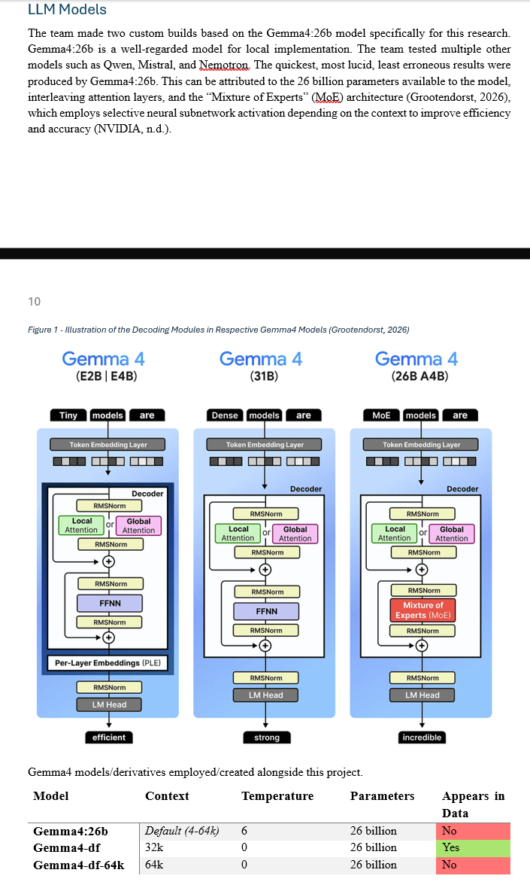

Tuesday, 20 October
1:00PM – 3:30 (2hrs 30min)
Working on individual closeout report. Cover, Topics, project, roles.
Wednesday, 21 October
10:30 – 1:00 (2hrs 30min)
More work on individual closeout report. Generating final timecard summary by looking through all logbooks. Summarizing each week’s worth of work.
2:00 – 6:00 (4 hours)
Continuing work on and finishing the individual closeout report. Ended up with 13 slides, too much writing, converted to written report based handin. To be clear on the type of work I completed, I need to get verbose.
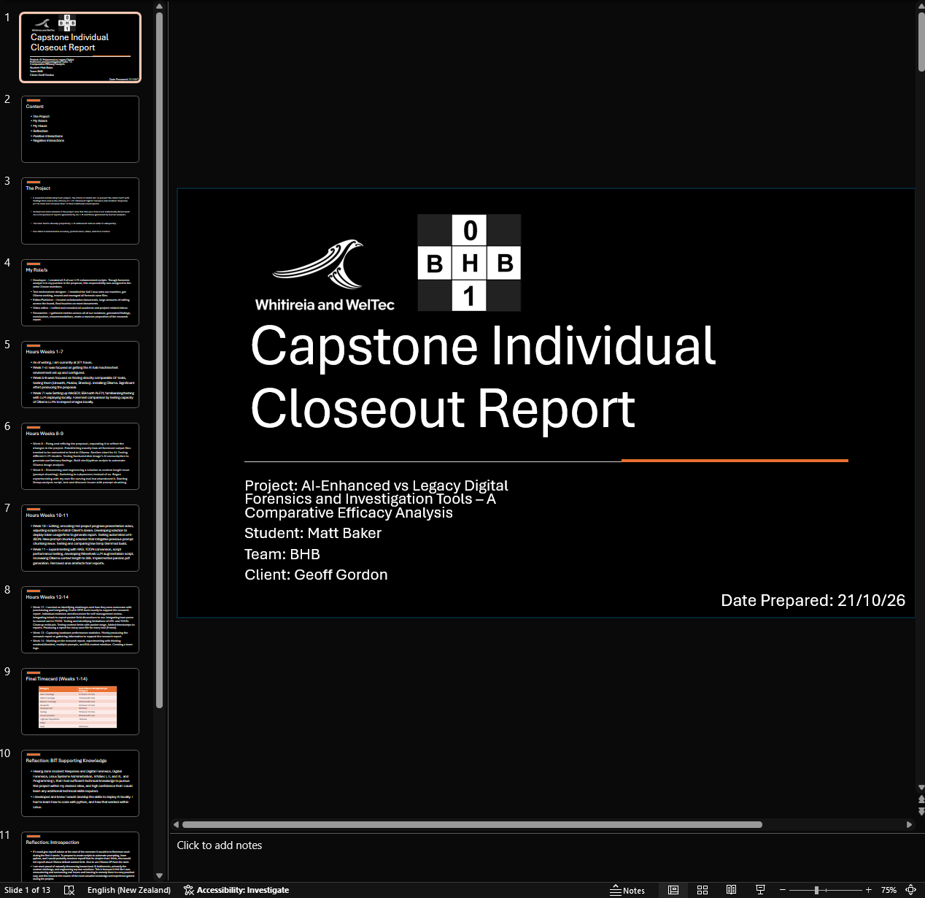

Thursday, October 22
11:45 – 2:00 (2hrs 15min)
Working on the research report. Inspecting Nmap reports for errors, traceability issues, editing recommendations, for future research, findings.
3:15 – 5:00 (1hr 45mins)
Creating a presentation for the team’s concluding review with Geoff tomorrow, delegating who will work on the slides.
5:00 – 6:00 (1hr)
Writing a finding I discussed with Olivia into the research report on non-comprehensive indications, investigating and collecting screenshots of report in question and Wireshark that support this.
7:15 – 8:15 (1hr)
Writing some of the research report conclusion, demonstrating maximum observed input context via experimental script.
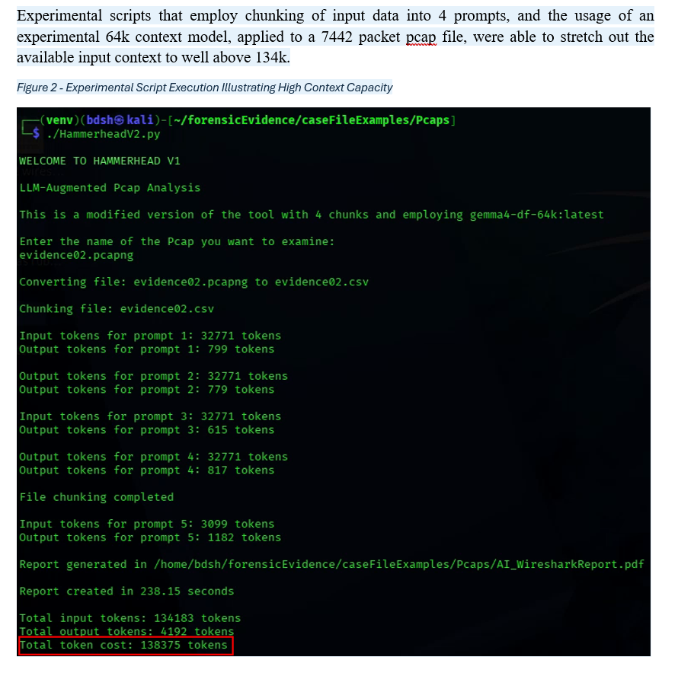
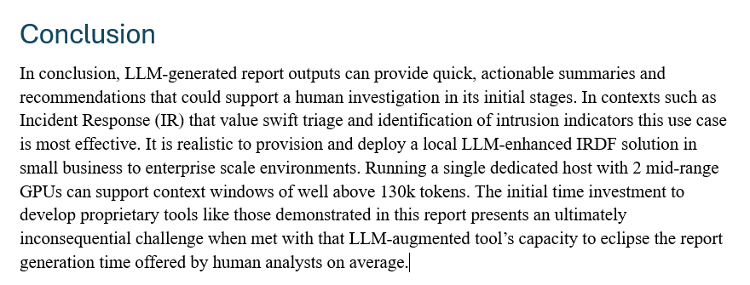

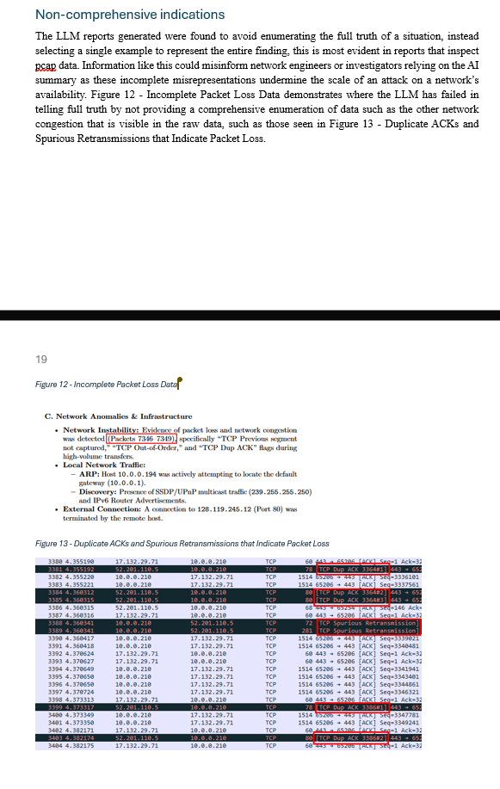
Saturday, October 24
3:45 – 5:45 (2hrs)
Work on client closeout report, added new w&w and bhb logo. Added work agreed to during the client concluding review meeting. Having to carve through the video to get the details. Adding additional details about the “key technologies”, adding more info about the models used on the research report and closeout report.
Sunday, October 25
11:00AM – 4:00PM (5 hrs)
Work on client closeout report.
Rewrote the project description as it was lacking.
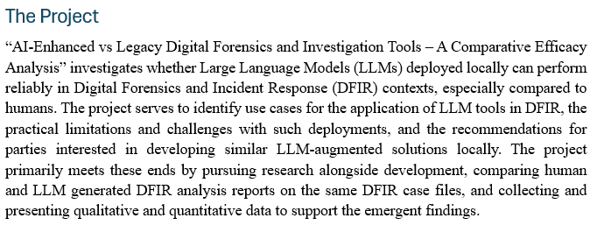
Added information that was lacking in all other areas, technologies section, handover specification, I am sure now that the document is complete. I also moved around my scripts and case files on the AI machine to make them easier to navigate to. I also added information to the tool manuals on features that support diagnostics/troubleshooting. I also added cleanup of .csv and .toon residual files to the scripts and tested to make sure that worked. It keeps the directories where you run the tool clean.
Figure 1 - No Residuals
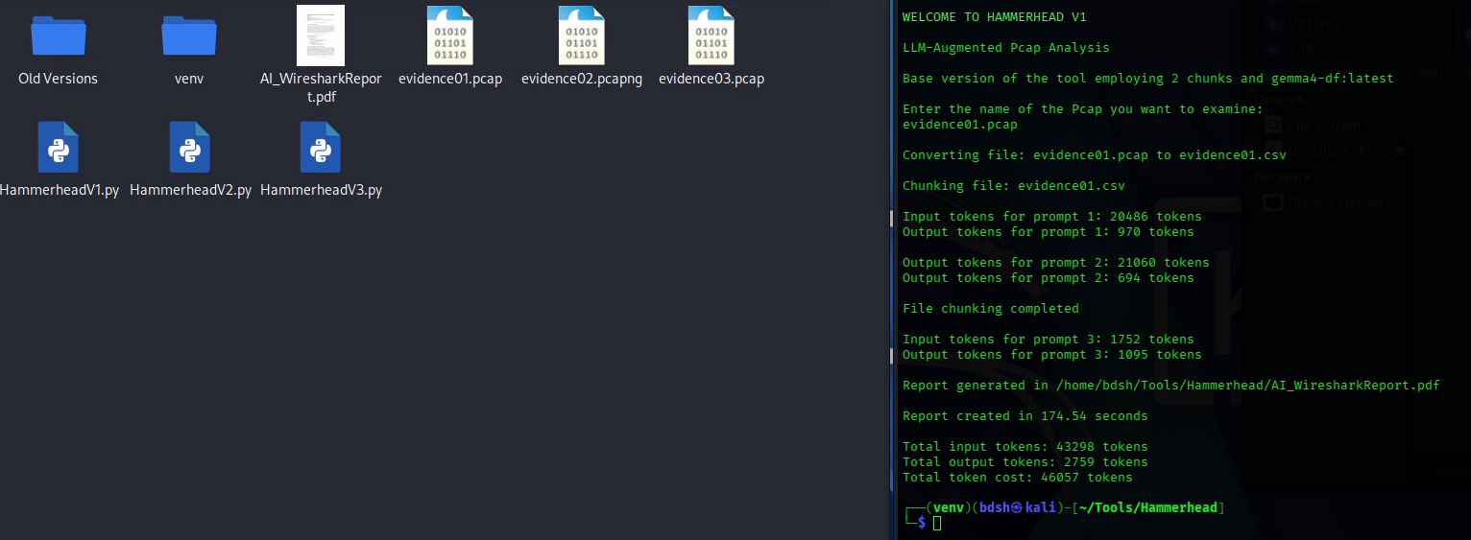

Testing
Saturday, October 24
1:45 – 3:00 (2hrs 15min)
Testing and attempting to fix HammerheadV3 that enables custom queries to look for specific data in the dataset rather than just asking for a general report.
Getting this error which often means ollama is inaccessible or not called right. Because of how long these prompts take, I only try once more with some modifications to the code. Was using 32k gemma4-df model for the very last prompt since its typically very short, but switch to 64k so all prompts use the same model. This does not work so I have to abandon the solution and move on to more important activities.
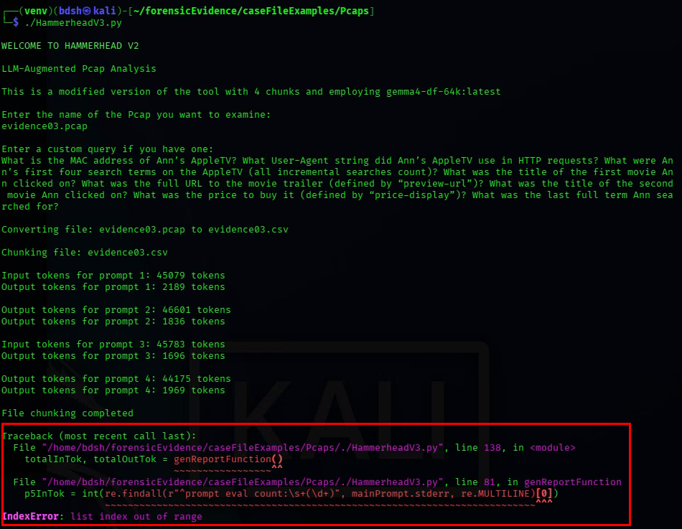

Development
Saturday, October 24
12:15 – 1:00PM (45 mins)
Trying to support the creation of a video and of the research report by developing an improvement to hammerhead (v3) to allow specific prompting as an input, so the script can handle custom queries. This helps by allowing me to ask the questions that have known answers from the source that hosts the pcaps.

